# Questions

1. The inline CSS has higher specificity.
2. Classes are not unique, while ID’s are. If you for example would prefer to apply the same style to several elements, classes are the way to go. Each element can only have one ID. (If not, the code will not pass validation). Elements can have BOTH a class and an ID.

ID: Lets say you want one specific line to be colored yellow

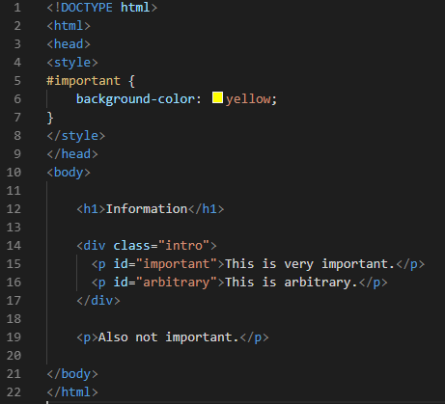

Result:

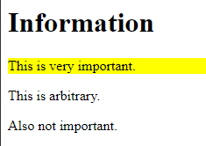

When using classes, you can impact several lines:

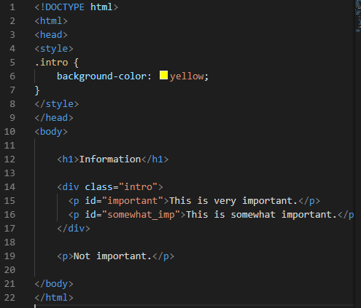

Result:

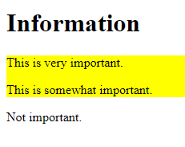

1. RGBA provides the value of (RED, GREEN, BLUE, ALPHA). The colors are self-explanatory. The alpha parameter Is a number between 0 (transparent) and 1 (opaque). You can express (256*256*256 = 16 777 216) colors with the RGBA scale. (256 is because you have to include the 0 value).
2. We include the CSS files in the head element because the browser renders the code from top to bottom (in a linear manner). If we include the CSS later on in the code, the site will render and present the HTML without the CSS for a very short time, then apply the CSS.
3. Two options: Child selector or decendant selector.

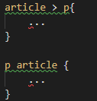

In this case, the first option is probably the preferred way to target the correct <p> tags.